APL numerical control and impulse compound flexible production line
2015-07-20 Jin Fangyuan, Jiangsu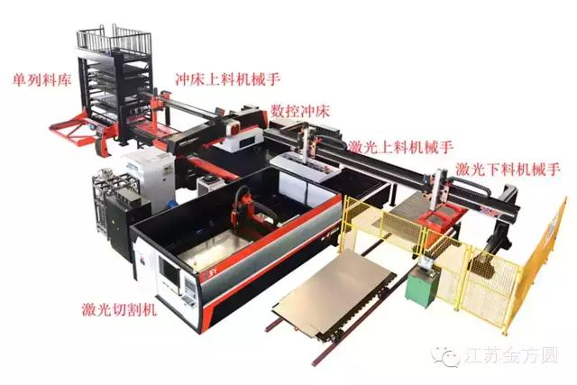
Now, with the increase of labor costs and the upgrading of industrial technology, sheet metal processing equipment is developing towards automation, intellectualization, flexibility and integration. The intelligent sheet metal factory, which is composed of laser cutting flexible production line, laser cutting and stamping, bending, welding and logistics, has come to a new opportunity.
CNC turret punch and laser cutting machine, as the key equipment of sheet metal processing, play an important role in today's sheet metal processing industry. Single machine CNC punching machine is inefficient and wasteful in the processing of parts with complex outlines, while single machine laser cutting machine can not achieve stretching and forming.
In order to give full play to their respective advantages of punch and laser cutting machine, Jiangsu Jin Fangyuan developed a APL impulse composite flexible production line, the production line to high intelligent production requirements, equipment by punch and laser cutting machine, material base system, feeding system and central control system. It can complete a series of automatic production processes, including plate feeding, outgoing storage, automatic feeding, punch processing, laser cutting, automatic blanking and so on, which is fast, accurate and reliable. And it can customize all kinds of special flexible production lines for customers.
Please watch the product demo video below

